Series vs Parallel circuits

Series

Current is the same across the whole circuit. Voltage split across components.

Parallel

Current is split across components. Voltage is the same across the circuit.

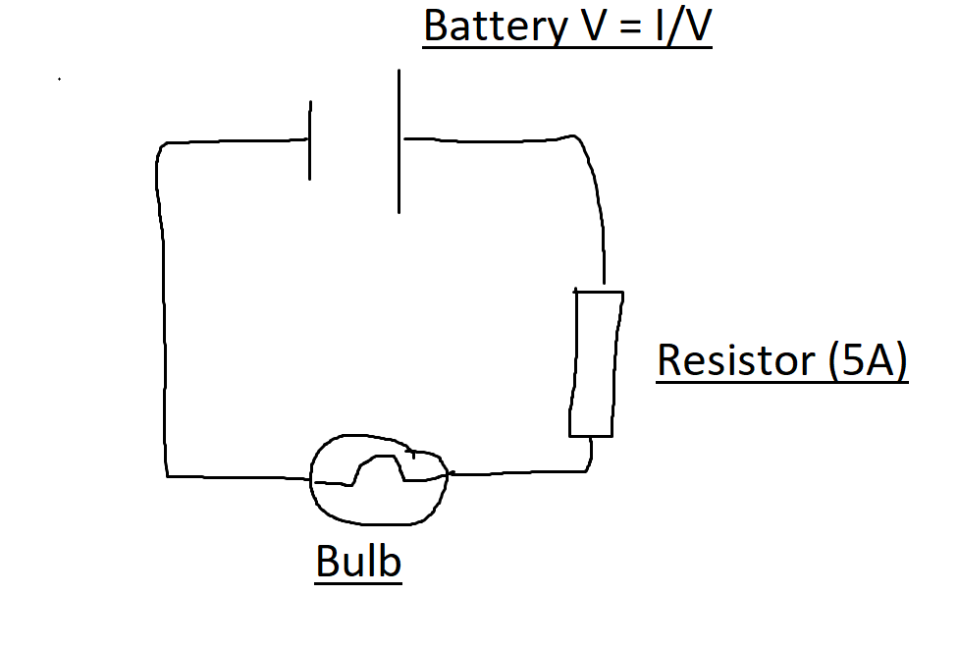

R=R(1)+R(2)+R(3)+…

1/R = 1/R(1) = 1/R(2) + 1/R(3)

Calculating the Capacitance in a circuit

\*Series

C=Q/V 1/C(s) = 1/C(1) + 1/C(2) + 1/C(3)

\*Parallel  
C(p) = C(1) + C(2) + C(3)

Exam Question – 2021 – Question 6 – B

Ohms Law:

V is proportional to current at a constant temperature

5 Bulbs w/ 9 Volt

Total Resistance : I/R = 1/5 + 1/5

I/R = 2/5

R= 5/2 = 2.5(Omega)

R= 5+ 5 + 2.5 = 12.5(omega)